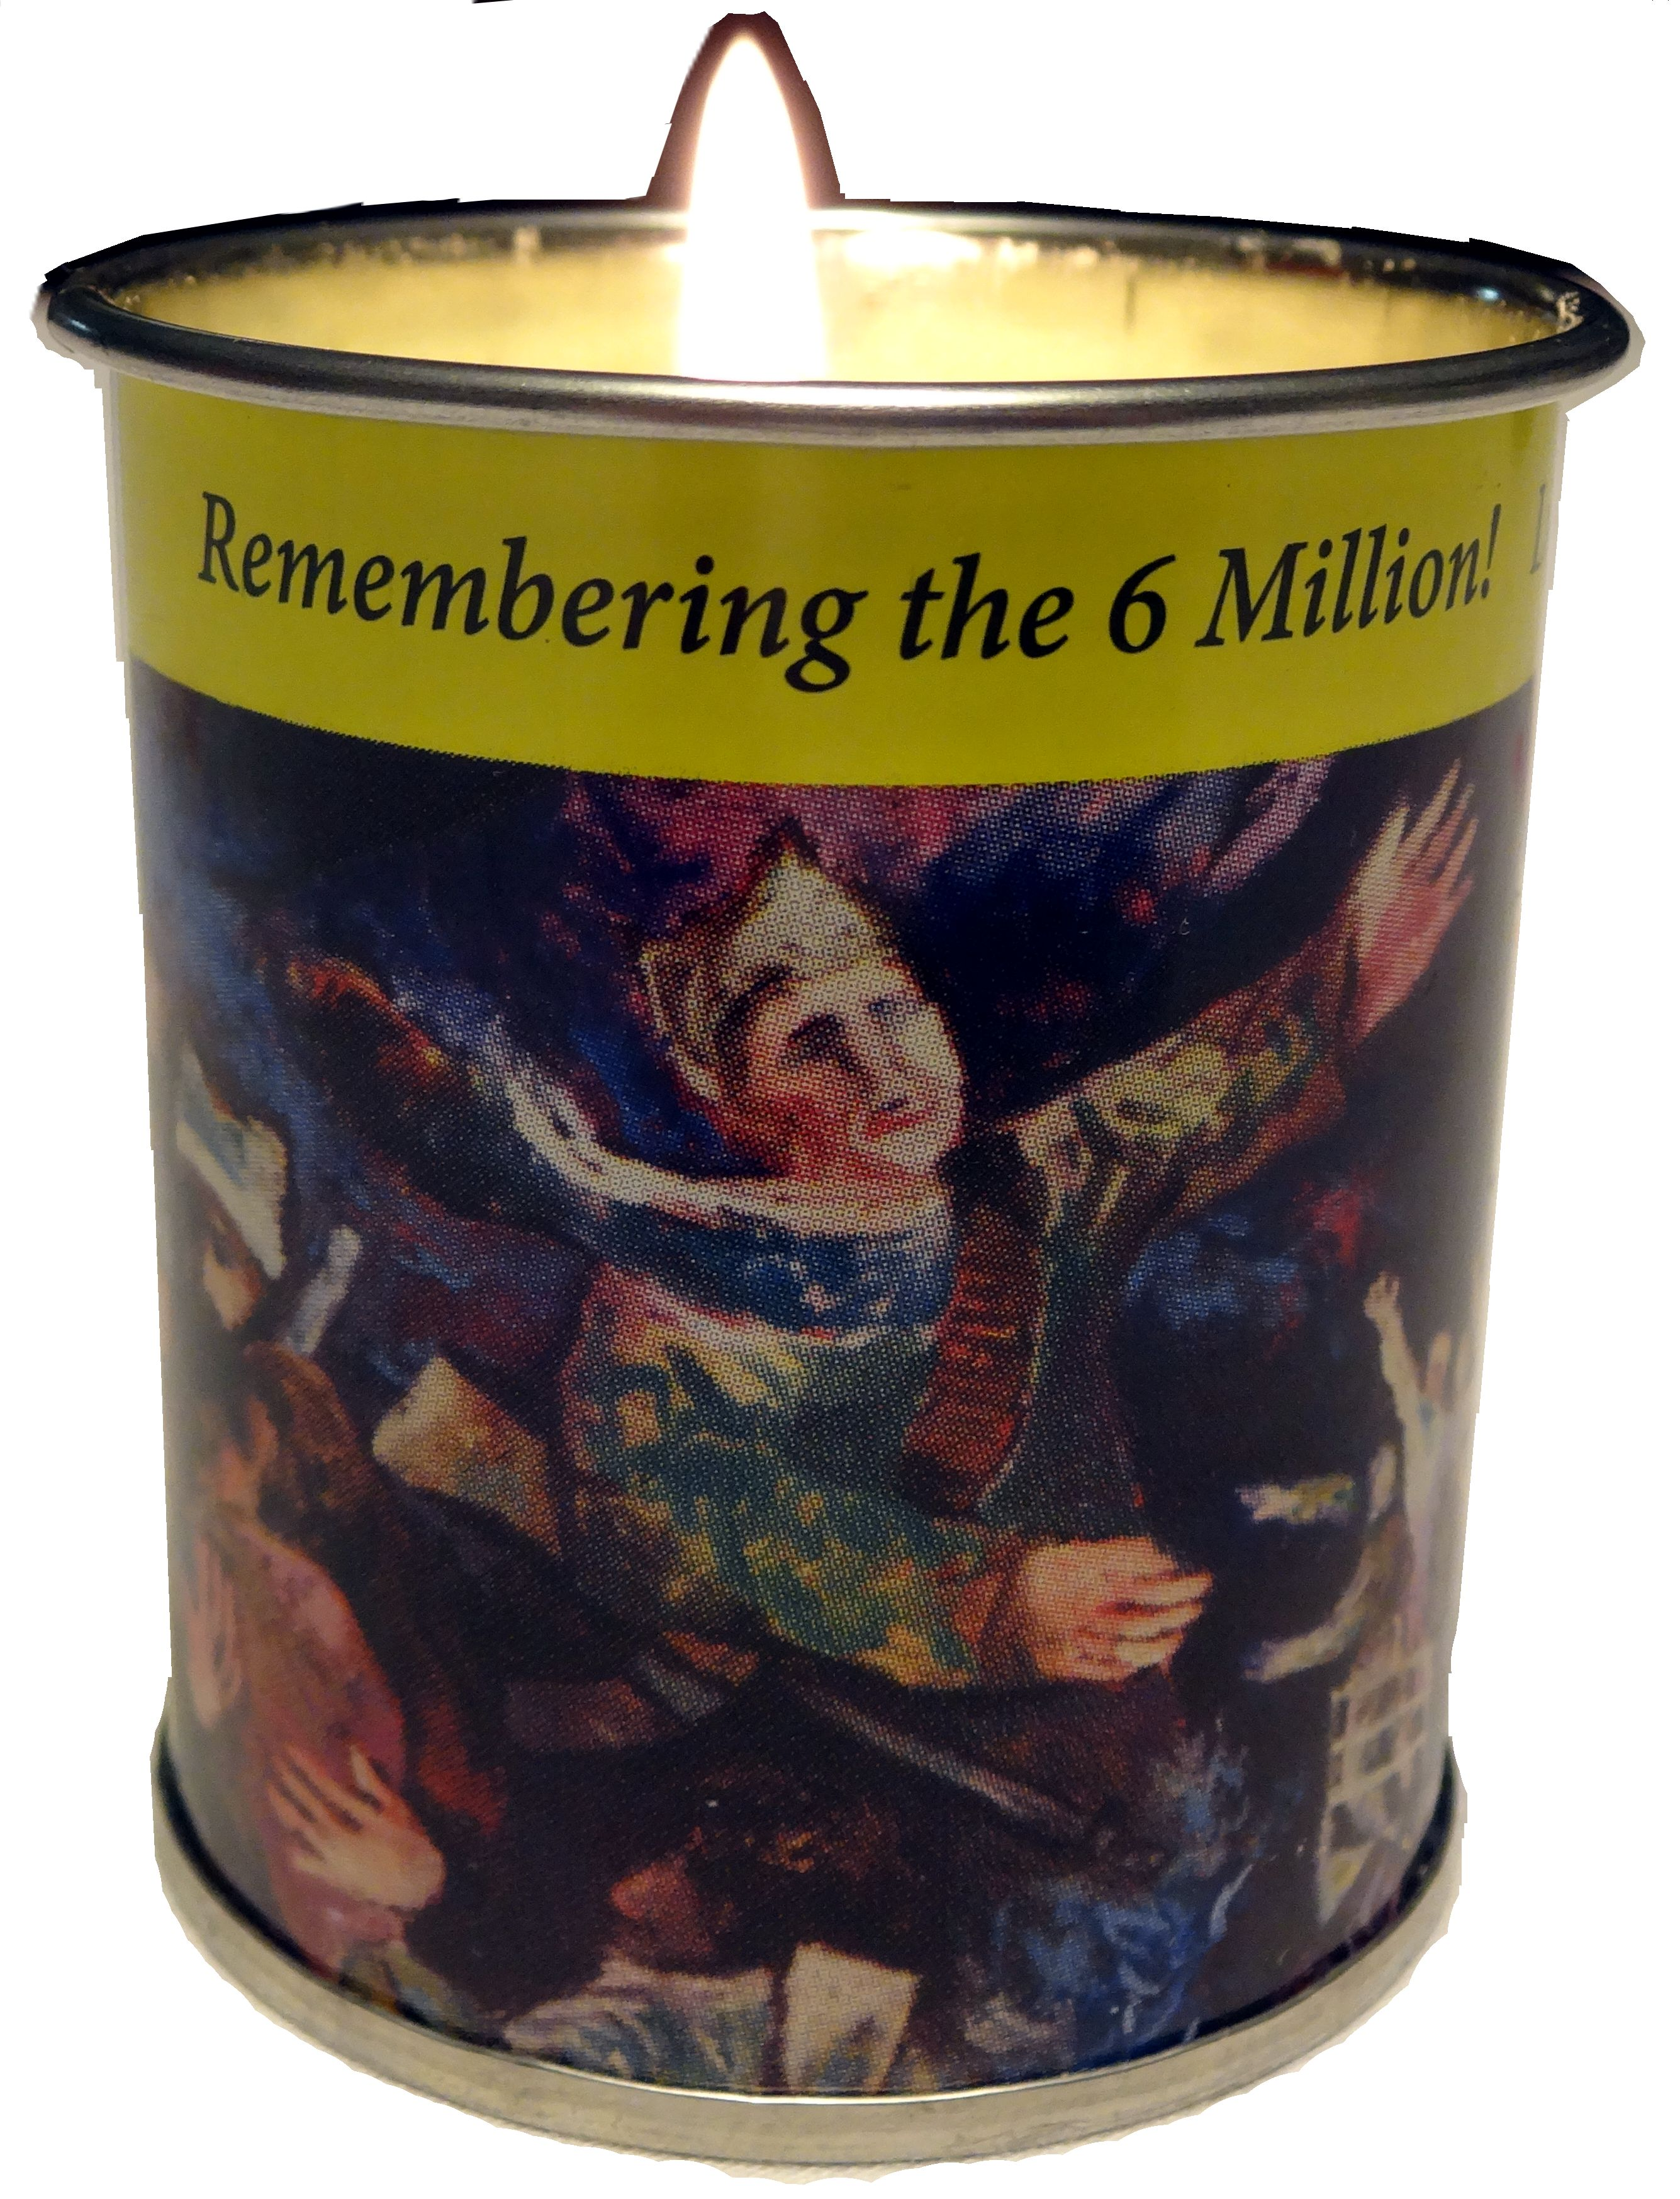
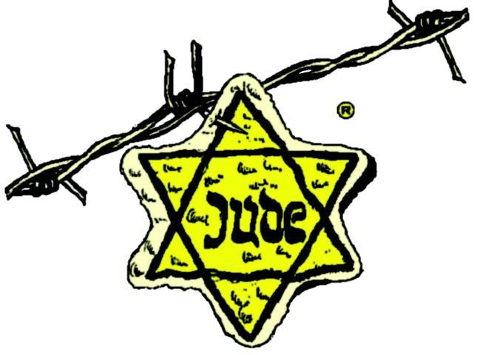

Meditation

Place the Yom HaShoah Yellow Candle in your window on the evening of
April 27, 2014 and recite the following as you light it.

As I light this Yellow Candle, I vow never to forget the lives of the Jewish men, women, and children who were martyred and are symbolized by this flame. They were tortured and brutalized by human beings who acted like beasts; their lives were taken in cruelty. May we be inspired to learn more about our six million brothers and sisters as individuals and as communities, to recall their memory throughout the year, so that they will not suffer a double death. May we recall not only the terror of their deaths, but also the splendor of their lives. May the memory of their lives inspire us to hallow our own lives and to live meaningful Jewish lives so that we may help to insure that part of who they were shall endure always.

MAY THEIR MEMORY BE A BLESSING FOR US ALL.”

“THOSE WHO DO NOT REMEMBER THE PAST
ARE CONDEMNED TO RELIVE IT.”

